**Mohammed Mahin Ibnay Mamun (346584)**

**Unit 11 Assignment**

**Task 3**

**Part 1 making assets**

My first design idea is planet earth. I will begin by choosing a large texture image of earth. Below is an image of the texture I have chosen.

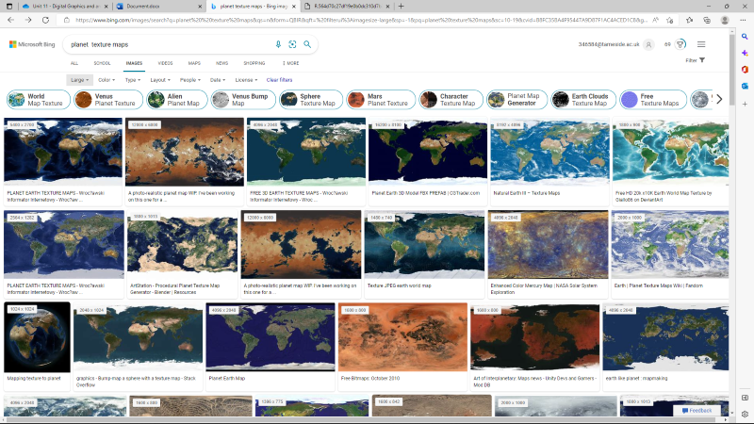

Source ([planet texture maps - Bing images](https://www.bing.com/images/search?view=detailV2&ccid=Vk1wwn3x&id=F7B1E02AE2D1850B6D8E7FF4BED180941A45965D&thid=OIP.Vk1wwn3xngsNwxDXs28tAQHaDt&mediaurl=https%3a%2f%2fth.bing.com%2fth%2fid%2fR.564d70c27df19e0b0dc310d7b36f2d01%3frik%3dXZZFGpSA0b70fw%26riu%3dhttp%253a%252f%252feoimages.gsfc.nasa.gov%252fimages%252fimagerecords%252f73000%252f73580%252fworld.topo.bathy.200401.3x5400x2700.jpg%26ehk%3dZN9y1kUKg9JOgktQ0m23CFx7riJdBXW%252bux0nI8bCFts%253d%26risl%3d1%26pid%3dImgRaw%26r%3d0&exph=2700&expw=5400&q=planet++texture+maps&simid=608029630031401786&FORM=IRPRST&ck=AB7BEAA82C5F0C1012E437FD1C358EAA&selectedIndex=0&qft=+filterui%3aimagesize-large&ajaxhist=0&ajaxserp=0)).

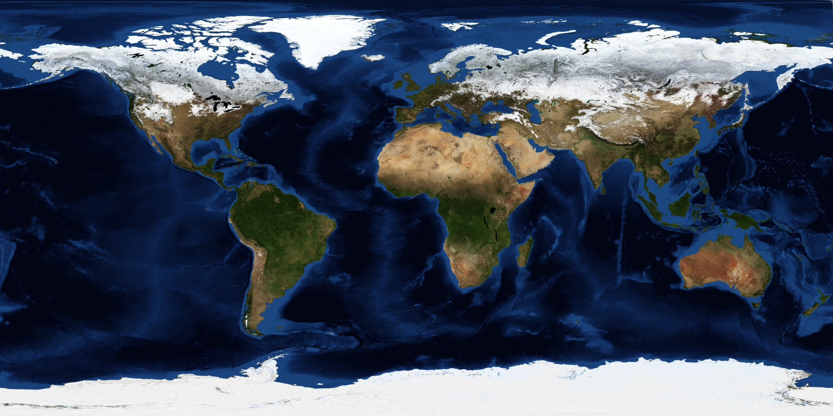

A few reasons why I decided to choose this image compared to others is because:

* The image is large with a vast number of pixels 5400 x 2700
* The image is quite detailed
* Image is clear
* Overall excellent quality
* No watermarks

Due to the fact the image has all the qualities listed above when I use it to as a material it will lose quality. Hopefully, this image will not lose as much because it starts off with particularly excellent quality.

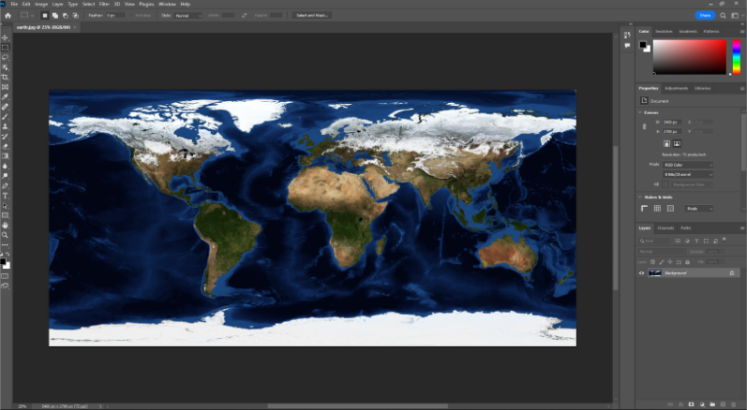I then opened up photoshop which will allow me to make my own edits to this texture. By creating a new layer and multiplying I can then use a soft brush to create designs

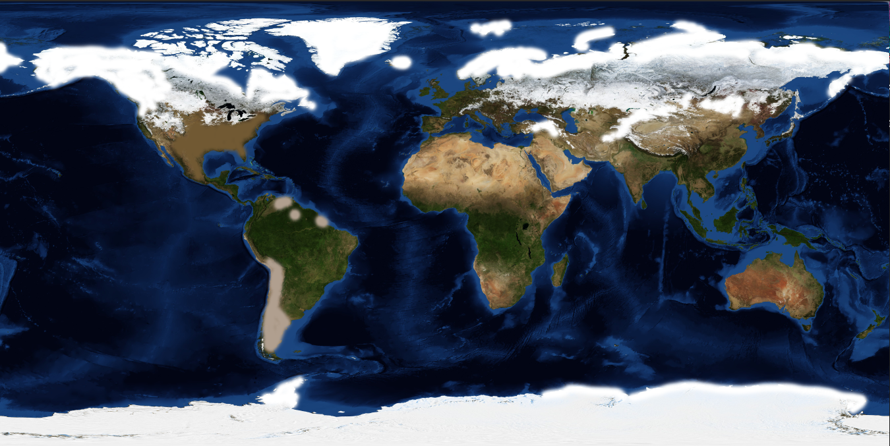

I then went into 3ds studio max, created a simple sphere, and set up a free light.

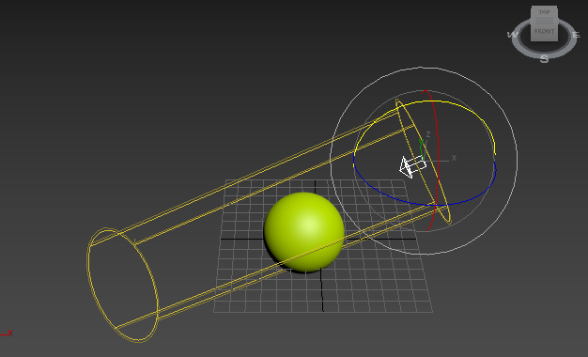

By setting the renderer to scanline rendering, I was able to produce the image shown below.

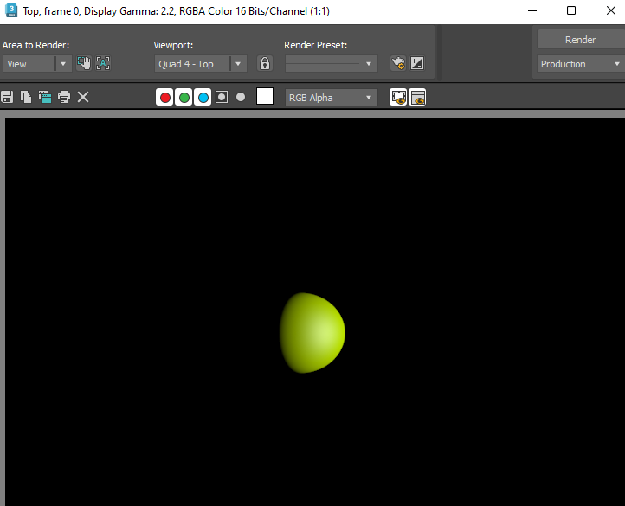

After I had my sphere created, I made a dark background color. Then I clicked on the rendering tab and opened the material editor. I then used these settings.

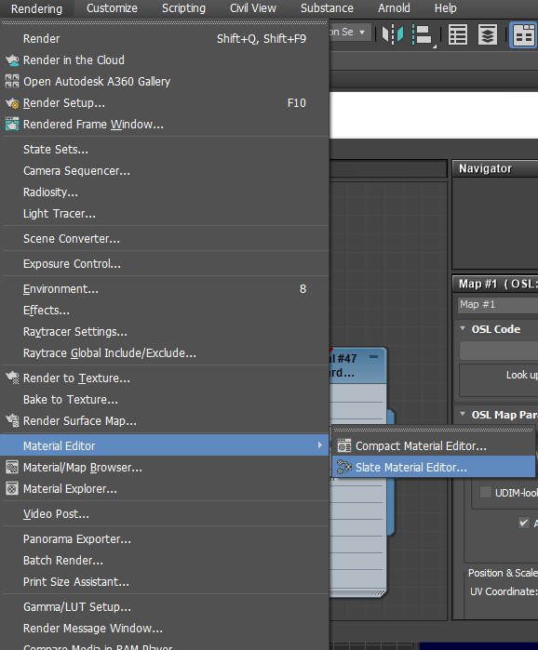

Create a Scanline – Standard material

Set:

* Self-illumination - color to black
* Specular level 1
* Glossiness 6

After this I went to the maps tab and chose diffuse color then I inserted my bitmap into the bitmap lookup tab.

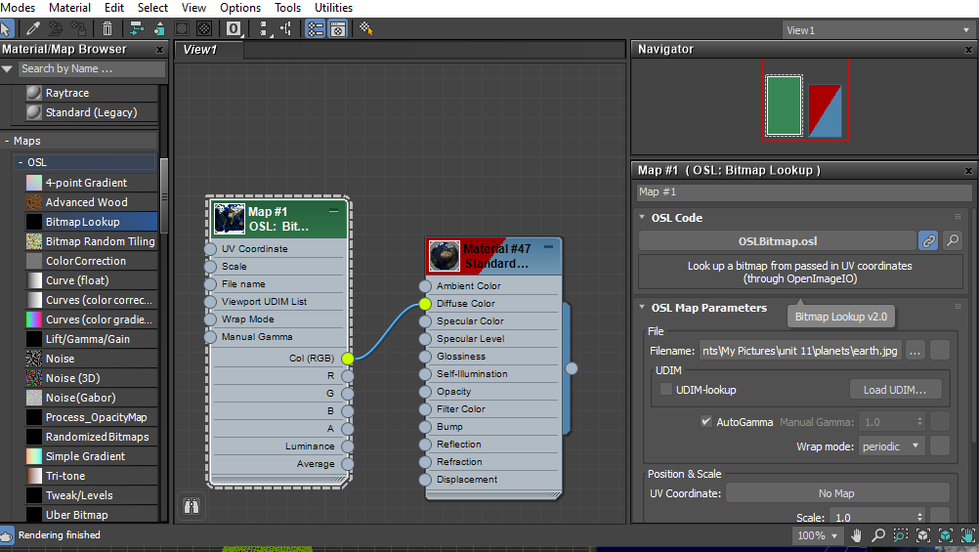

After I selected my image from photoshop, I dragged the color GBB line and attached it to diffuse color. Then I dragged the circle on the right and attached it to my sphere.

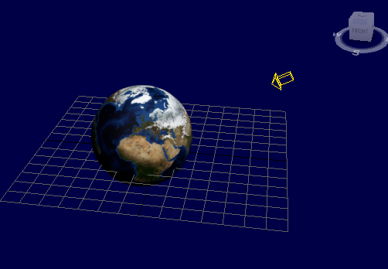

Finally, my project looked like this. I then used the rotating tool to spin my sphere around to get a better angle.

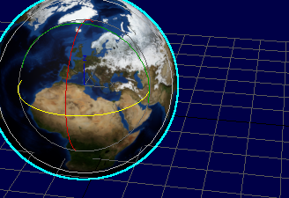

My final design looked like this.

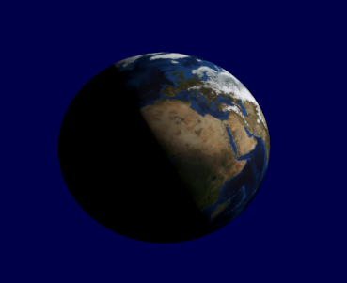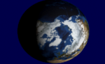

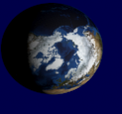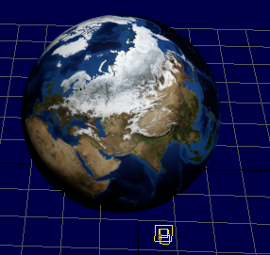

I used this same technique for the rest of my planets.

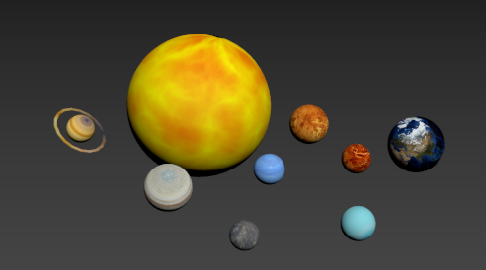

**Designs for the images/models**

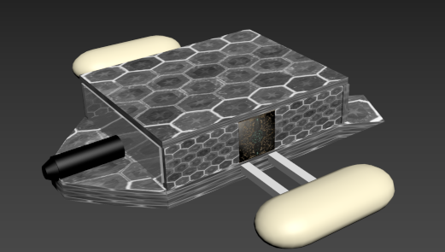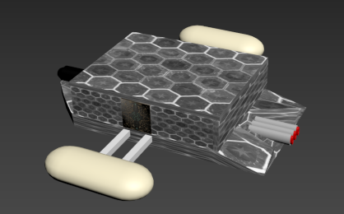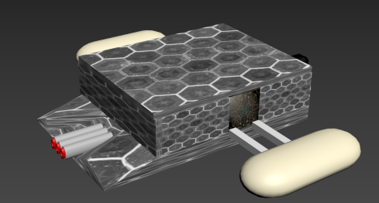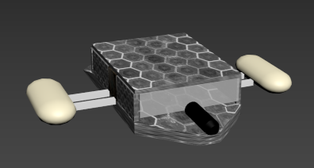

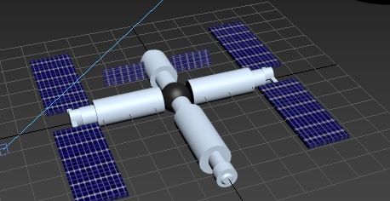

To create these models, I began by finding a shape. On the right-hand side of standard primitives was a list of shapes I could use.

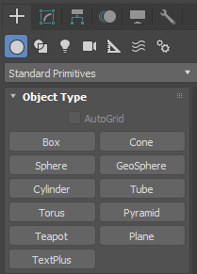

 These were the three main tools which I used. The first tool allowed me to move objects and shapes around. Here is a screenshot of the tool in action.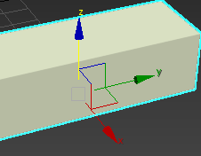 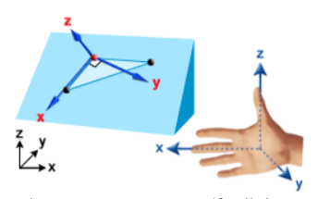

The term local is being used here.

 moving onto the rotating tool which is used to turn around objects and pieces. Once again, the local technique is used.

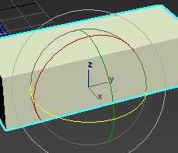

Finally, the scale tool is especially useful to resize the object.

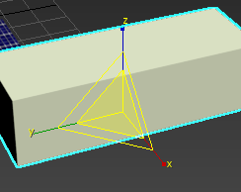 I have access to rescale the sides of images Aswell as height. I can also elevate the shape up and down.

I used the group tool once I had a few shapes built and arranged together. This is a helpful tool that enables me to combine numerous particles into a single entity. If I tried to move the shapes without grouping them, it would only move the currently selected shape. I have grouped them together as a result, and I can now move the entire product made up of various forms. The anchor tool is comparable to this tool (group).

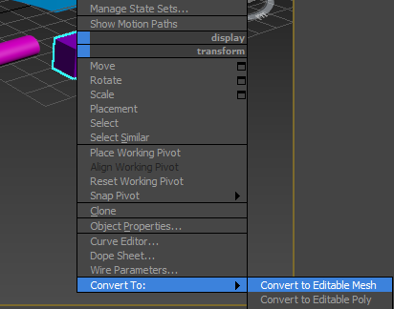

I used the convert to tool to make my shapes an editable mesh. This allows me to use more features. I used 2 common features from this option which are extrude and bevel.

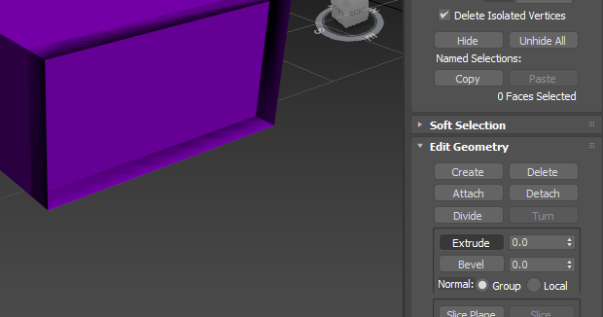

Above is a screenshot of my using the extrude tool. This tool is used to push in and pull-out shapes. I used this tool quite a lot in my design. Here is another example. I used one box and managed to push out the sides to make this design. 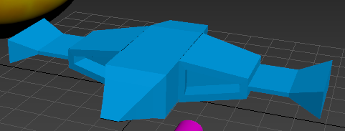

I also used the bevel tool which allowed me to make points for my shapes.

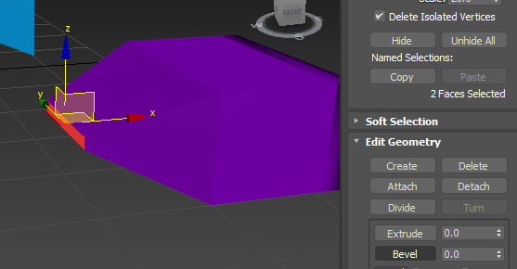

**Before grouping tool** 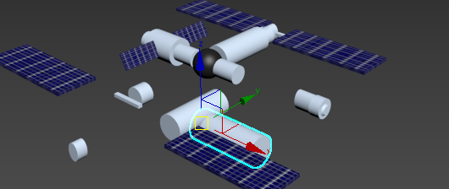 I used several parts and clustered them together to form a space station. I skipped the group tool. When I tried to move a piece using the move tool, it just moved that one piece. The steps below must be taken to group parts.

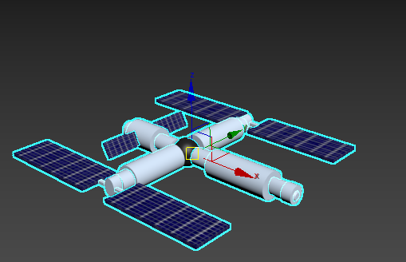

First, I got all the pieces and moved them to where I wanted them. The pieces are not grouped so they will move each shape one by one.

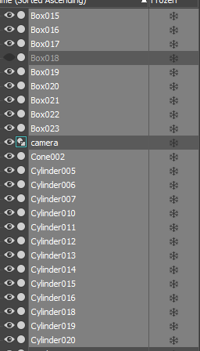

As you can see above is a list of all the shapes which I used. I did not name them because I will make them all into one shape at the end.

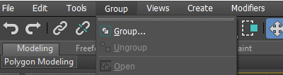 Once I selected all my shapes which I wanted to group, I selected the menu at the top and select group.

**\*Add light and camera\***

**Part 2 creating animation**

The first step I carried out for making the animation was setting the time configuration.

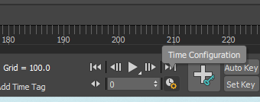

After selecting the option and chose to set my time frames to 250.

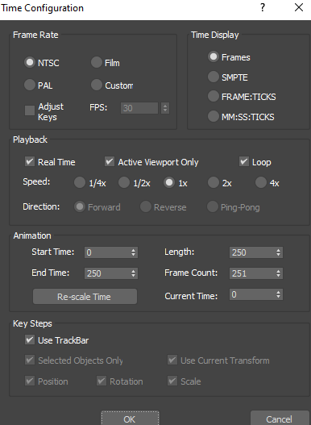

I also had to change my option to 250 frames in rendering.

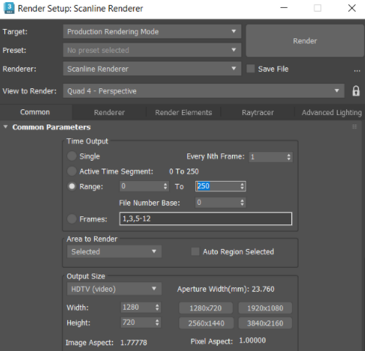

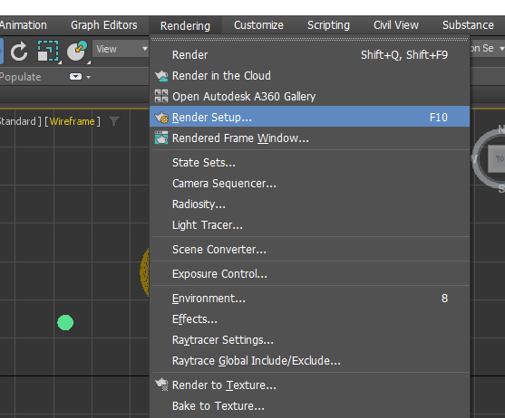

After I recorded the video by moving the object at the end, I saved the video as an Avi file.

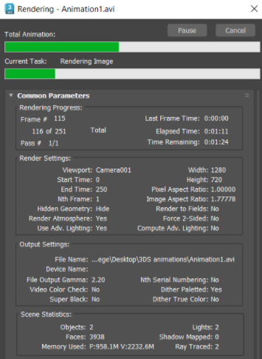

I repeated these steps and created a few more videos, after I had a few videos, I used video editor to make it all one clip.

The video editor I used was Clipchamp.

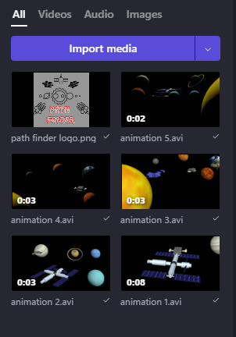

I imported all the videos which I wanted to use then I dragged them all down onto the timeline, just like any other video editing software.

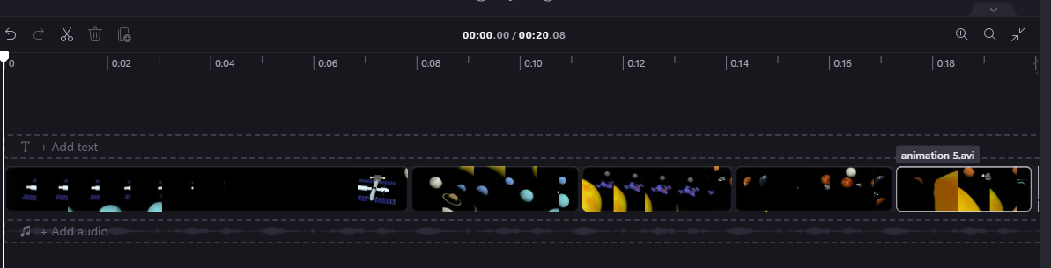

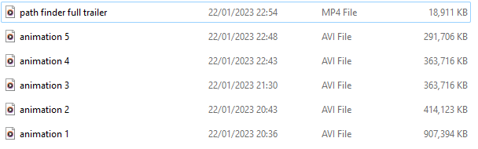

**Evaluation**

Overall, this project was quite challenging and very new to me, but it was a lot of fun learning about and trying it out. In this project I learnt a lot of theory about graphics which helped me to build my result. Using 3ds max is new to me. However, it is an incredibly fun software to use so I will be practicing it more. I found it quite hard to make certain models, for example ships. As I was very clueless about the tools and how to use them. After doing independent research, my knowledge of this software has improved. I have learnt so many new tools and techniques which I did not know before. This was my first-time adding texture to an object, I found it hard at first but after applying it 7+ times for all my planets I know how to do it now.

My design for this project does meet the requirements which were requested. I have created a logo for the stream. This trailer is user friendly. I have added planets, space stations, ships, and enemy ships. The trailer also consists of the enemy ship getting taken down and it stays in the time limit.

Overall, I feel like I was creative with my initial plan, however, the product could have been better. I was expecting a better result. As I started putting my ideas into the project, there were a lot of things which I was unable to do. I did some independent research and found the solution to some. The reason I was unable to create my initial plan was a lack of time. Having exams, college and work capped my time limits. I will keep this in mind for my next tasks and see how I can manage time better so I can produce a better task.

I managed to complete everything in this task, however I feel if I had a little bit more time, I could have made some big improvements. For example, my first ship, after completing more drafts on ships I got better designing them and I used one for my enemy ship. However, it would take too long for me to recreate another, so I did not re do it. I also wanted to add to the video when the ship takes down the enemy, I was planning to make letters fall from the enemy ship which could spell out path finder. However, when I tried to it was taking far too long to make the letters and then I would have to somehow fit them all in the ship which is very tricky to do. At the end I wanted the ship to shoot out the characters and spell path finder. Due to lack of time, I was not able to do this so instead I just put the logo at the end of the video.